Name: Mohammad Abu Obaida

Registration No: 23-NTU-CS-1052

Class: BSCS-5th -B

Section: CS-B

Question-1 ESP32 Webserver (webserver.cpp)

Part A: Short Questions
- What is the purpose of WebServer server(80); and what does port 80 represent?
WebServer server(80); is used to create a web server on the ESP device so it can host a webpage and communicate with web browsers. This allows users to access sensor data or control the device through a browser.
Port 80 is the default port for HTTP communication. When a user enters the IP address of the ESP in a browser, the request is sent through port 80 automatically, which is why it is commonly used for web servers.

- Explain the role of server.on("/", handleRoot); in this program.
This line tells the web server what to do when a user opens the main page of the server. The symbol / represents the home or root page.
When someone opens the ESP’s IP address in a browser, the function handleRoot() is called, and it sends the webpage content to the user.

- Why is server.handleClient(); placed inside the loop() function? What will happen if it is removed?
server.handleClient(); is placed inside the loop() function so that the ESP continuously checks for incoming client requests.
Since loop() runs again and again, this function keeps the server responsive. If it is removed, the server will not process any browser requests, and the webpage will not load or update properly.

- In handleRoot(), explain the statement: server.send(200, "text/html", html);
This statement is used to send a response to the client’s browser.
The value 200 means the request was successful. "text/html" tells the browser that the content being sent is an HTML webpage. The variable html contains the actual webpage code that will be displayed in the browser.

- What is the difference between displaying last measured sensor values and taking a fresh DHT reading inside handleRoot()?
Displaying the last measured sensor values means the webpage shows previously stored readings, which were taken earlier in the program. This makes the page load faster and avoids unnecessary sensor readings.
Taking a fresh DHT reading inside handleRoot() means the sensor is read every time the page is refreshed. This gives real-time data but can slow down the response and may cause errors because DHT sensors need some delay between readings.

Part B: Long Question

Complete Working of the ESP32 Webserver-Based Temperature and Humidity Monitoring

SystemThis system is designed to measure temperature and humidity using a DHT22 sensor and display the values both on an OLED screen and on a web page hosted by the ESP32. The ESP32 acts as a web server, allowing users to view sensor data through a browser over Wi-Fi.

ESP32 Wi-Fi Connection Process and IP Address Assignment: At startup, the ESP32 initializes serial communication and then begins connecting to the Wi-Fi network using the provided SSID and password. The connection process continues in a loop until the ESP32 successfully connects to the network. During this time, connection status messages are displayed on the OLED and Serial Monitor. Once connected, the router automatically assigns a local IP address to the ESP32 using DHCP. This IP address is later used to access the web page hosted by the ESP32 from any device connected to the same network.

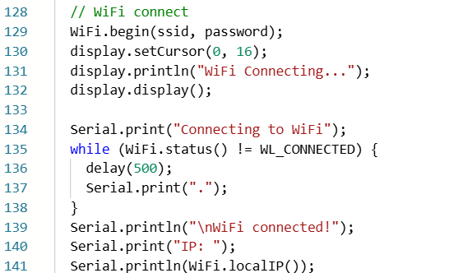

Web Server Initialization and Request Handling: After establishing the Wi-Fi connection, a web server is created on port 80, which is the standard port for HTTP communication. The server is configured so that when a client accesses the root URL (/), the function handleRoot() is executed. The web server is started using server.begin(). Inside the main loop, server.handleClient() continuously listens for incoming requests and processes them, ensuring that the web page loads and refreshes correctly whenever a user accesses the ESP32’s IP address.

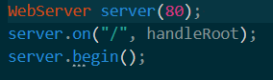

Button-Based Sensor Reading and OLED Update Mechanism: A push button is connected to the ESP32 using the internal pull-up resistor. The system continuously checks the button state inside the loop. When a button press is detected (falling edge), the ESP32 reads temperature and humidity values from the DHT22 sensor. These values are stored as the latest readings and then displayed on the OLED screen. This method prevents unnecessary sensor readings and ensures that data is only updated when the user presses the button.

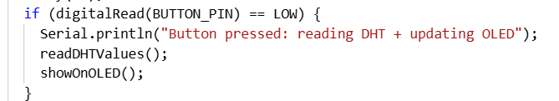

Dynamic HTML Webpage Generation: The web page is generated dynamically inside the handleRoot() function using an HTML string. This webpage displays the latest temperature and humidity values stored in the system. If no valid sensor data is available, the webpage shows a message asking the user to press the button to take a reading. The ESP32 sends this HTML page to the browser using an HTTP response with a success status code, allowing real-time monitoring through a web interface.

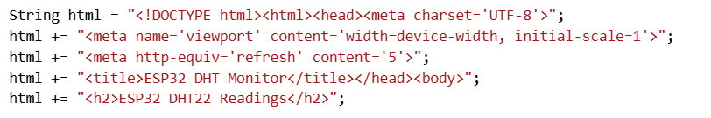

Purpose of Meta Refresh in the Webpage: The meta refresh tag in the HTML page automatically refreshes the webpage after a fixed time interval. This allows the browser to periodically update and show the latest sensor readings without requiring the user to manually reload the page. It helps in keeping the displayed data up to date in a simple and effective way.

Common Issues in ESP32 Webserver Projects and Their Solutions: One common issue is unstable Wi-Fi connectivity, which can prevent the web page from loading. This can be solved by ensuring a strong network signal or reconnecting the ESP32 properly. Another issue is frequent sensor reading errors, especially with DHT sensors, which occur if readings are taken too often. This is avoided by reading the sensor only when the button is pressed. Sometimes the web server becomes unresponsive if server.handleClient() is not called continuously; placing it inside the loop solves this problem. OLED display issues may occur due to incorrect I2C address or wiring, which can be fixed by verifying hardware connections and initialization.

Question-2 Blynk Cloud Interfacing (blynk.cpp)

Part-A: Short Questions
- What is the role of Blynk Template ID in an ESP32 IoT project? Why must it match the cloud template?
The Blynk Template ID is used to link the ESP32 firmware with a specific device template created on the Blynk Cloud. This template defines things like virtual pins, widgets, and data layout used in the Blynk dashboard. It must match the cloud template so that the ESP32 sends data to the correct project. If the Template ID does not match, the device will not connect properly and data will not appear on the dashboard.

- Differentiate between Blynk Template ID and Blynk Auth Token.
The Blynk Template ID identifies the project or device template on the Blynk Cloud and is usually the same for all devices using that template. The Blynk Auth Token, on the other hand, is unique for each device and is used for authentication. The Template ID defines what the device is, while the Auth Token verifies which specific device is connecting.

- Why does using DHT22 code with a DHT11 sensor produce incorrect readings? Mention one key difference between the two sensors.
Using DHT22 code with a DHT11 sensor produces incorrect readings because both sensors have different data formats and specifications. One key difference is that the DHT22 has higher accuracy and can measure a wider range of temperature and humidity, while the DHT11 has limited range and lower precision. Because of this difference, the sensor data is interpreted incorrectly when the wrong sensor type is used in the code.

- What are Virtual Pins in Blynk? Why are they preferred over physical GPIO pins for cloud communication?
Virtual Pins in Blynk are software-based pins used to send and receive data between the ESP32 and the Blynk Cloud. They do not correspond to any physical pins on the microcontroller. Virtual Pins are preferred because cloud data does not depend on hardware wiring, and multiple values like sensor readings can be sent easily without using actual GPIO pins, making the system more flexible and scalable.

- What is the purpose of using BlynkTimer instead of delay() in ESP32 IoT applications?
BlynkTimer is used to run tasks at regular intervals without stopping the program. Unlike delay(), it does not block the execution of important functions such as Blynk communication and button detection. Using delay() can cause the ESP32 to disconnect from the Blynk server, while BlynkTimer allows smooth multitasking and reliable cloud connectivity.

Part-B: Long Question
- Creation of Blynk Template and Datastreams: Before programming the ESP32, a device template is created on the Blynk Cloud. This template defines how data will be displayed in the Blynk dashboard. Datastreams are created inside the template using virtual pins (for example, V0 for temperature and V1 for humidity). These datastreams act as channels through which the ESP32 sends sensor data to the cloud.

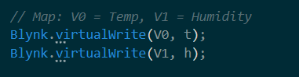

- Role of Template ID, Template Name, and Auth Token: The Template ID uniquely identifies the Blynk template used by the device. The Template Name is a human-readable name for the project. The Auth Token is a unique key assigned to each device and is required to authenticate the ESP32 with the Blynk Cloud. All three must match the cloud configuration, otherwise the device will fail to connect. The ESP32 connects to a Wi-Fi network and then establishes a secure connection with the Blynk Cloud using the Auth Token. This allows real-time data exchange between the ESP32 and the mobile or web dashboard.

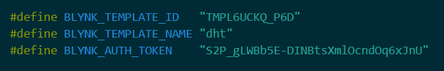

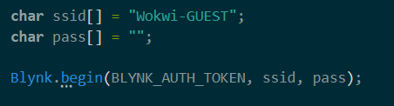

- Sensor configuration issues (DHT11 vs DHT22): The DHT sensor type must match the hardware used. Using DHT22 code with a DHT11 sensor causes incorrect readings because both sensors have different resolution, accuracy, and data formats. The DHT22 supports a wider temperature range and higher precision compared to the DHT11.

- Sending data using Blynk.virtualWrite() : After successful sensor reading, the ESP32 sends the temperature and humidity values to the Blynk Cloud using virtual pins. These values are then displayed on gauges or labels in the Blynk dashboard. BlynkTimer is used to send data at regular intervals without blocking the program. This ensures stable cloud communication and avoids disconnection issues that occur when using delay(), timer.setInterval(5000L, periodicSend);.

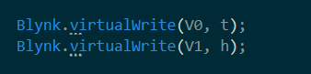

- Common problems faced during configuration and their solutions: One common problem is device offline status, which usually occurs due to incorrect Auth Token or Template ID. This can be fixed by copying the correct credentials from Blynk Cloud. Another issue is wrong sensor readings caused by using DHT11 code for a DHT22 sensor; this is solved by selecting the correct sensor type in the code. Wi-Fi instability can also interrupt data updates, which is handled by using Blynk.run() and BlynkTimer instead of blocking delays.
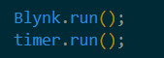

BLYNK WEB DASHBOARD

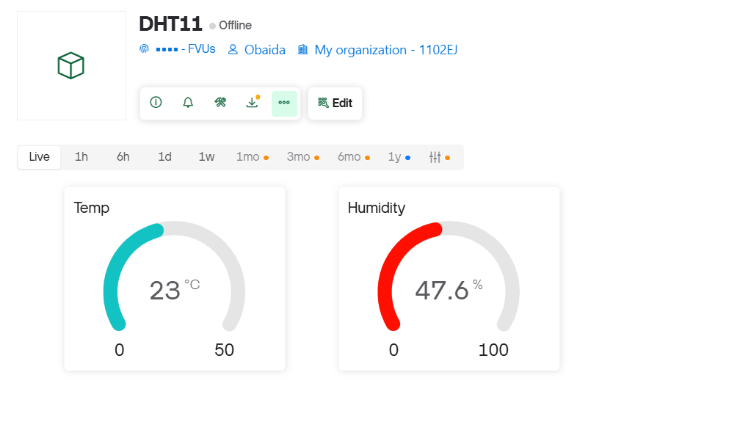

MOBILE DASHBOARD:

